Machine Learning-Based Intrusion Detection Framework Trained on the UNSW-NB15 Dataset for Cloud Environments

Dr Nagaraja G (professor and HOD) Kiran Sagar S Yashwanth Kumar A S
Dept of AI & DS Dept of AI & DS Dept of AI & DS
SJCIT, Chikkaballapura SJCIT, Chikkaballapura SJCIT, Chikkaballapura
Karnataka, India Karnataka, India Karnataka, India
hodaids@sjcit.ac.in kiransagar1718@gmail.com yashwanthkumaras7@gmail.com
Yashwanth T R Harshal Volety
Dept of AI & DS Dept of AI & DS
SJCIT, Chikkaballapura SJCIT, Chikkaballapura
Karnataka, India Karnataka, India
yashwanthtr32@gmail.com abhilashabhi@gmail.com

Abstract : Cloud computing has become a prevalent paradigm for delivering scalable computational resources over virtualized infrastructures, yet it continues to exhibit serious security shortcomings that render systems susceptible across multiple types of cyberattacks. Conventional intrusion detection mechanisms, largely dependent on pre-established signatures, often fail to detect unfamiliar or evolving threats effectively. This study proposes a machine learning-driven intrusion detection model aimed at strengthening anomaly identification in cloud environments. Experiments conducted using the UNSW-NB15 dataset show that ensemble-based algorithms, especially Random Forest, deliver strong detection performance with an accuracy of approximately 97.68%. The findings emphasize the promise of machine learning methods in identifying malicious activity and improving the overall security of cloud systems.
Keywords: Cloud security, network threat detection, intelligent classification, cyberattack mitigation, UNSW-NB15 dataset.

1 . INTRDUCTION
Cloud computing has grown into a leading system designed to offer computing resources, software applications, and data storage services through internet-based platforms. Its on-demand provisioning model enables organizations to scale resources dynamically, reduce infrastructure investments, and enhance operational efficiency. cloud services are widely embraced across industry, academic research, and government organizations, supporting diverse applications such as data analytics, large-scale processing, and distributed service management.While the cloud offers significant economic and technological advantages, it also introduces a broad range of security risks due to its shared, virtualized, and remotely accessible nature. Attackers can exploit cloud vulnerabilities to perform unauthorized access, disrupt services, compromise data integrity, or seize control of infrastructure resources. The distributed nature of cloud systems further compounds these risks, creating complex attack surfaces that are difficult to secure using traditional methods.

2. LITERATURE REVIEW:
Ensuring the security of cloud environments has become a critical research focus as organizations rely more heavily on remote data storage, virtualization technologies, and distributed computing models. Traditional intrusion detection approaches, particularly signature-based techniques, have been successful in identifying previously known attacks. Yet, they struggle to address rapidly evolving threats, zero-day exploits, and the high-volume traffic patterns that characterize modern cloud environments.This limitation has encouraged researchers to investigate machine learning-based intrusion detection techniques capable of adapting to emerging attack behaviors.
Initial research focused on applying conventional supervised learning methods to identify abnormal patterns in network traffic. These models typically displayed satisfactory results once trained on labeled intrusion datasets. However, they often faced limitations such as sensitivity to redundant features, imbalanced class distributions, and high computational costs. To address these challenges, subsequent studies incorporated feature selection techniques to eliminate unnecessary attributes and enhance detection accuracy, particularly in high-dimensional network environments.
Ensemble learning is gaining widespread adoption because it integrates multiple learning models to enhance classification performance. Approaches like Random Forest, Extra Trees, and Gradient Boosting have shown improved results over to single classifiers, largely due to their capability to capture non-linear relationships and effectively generalize across different attack categories. Studies also indicate that ensemble methods can fewer false positives, with the increasing scale and complexity of cloud-based applications, many researchers have examined the potential of deep learning approaches to identify sophisticated behavioral patterns in network traffic. Neural architectures, including convolutional and recurrent models, have been analyzed for their ability to automatically extract spatial and temporal characteristics, thereby reducing dependence on manual feature engineering. Such models have yielded positive findings in detecting advanced attacks, but they often demand large training datasets and high processing capacity, which may limit their suitability for real-time environments.
A related direction in prior studies focuses on hybrid or multi-layered intrusion detection systems. These approaches typically integrate signature-based mechanisms for identifying known attacks utilizing machine learning models designed to detect anomalies. The aim is to achieve rapid identification of common threats while maintaining adaptability to new or unseen attack behaviors. Prior work demonstrates that hybrid frameworks can improve overall detection accuracy and simultaneously reduce false alarm rates.
Researchers have noted multiple persistent challenges in the creation of machine learning-driven intrusion detection systems. These include the imbalance between malicious and legitimate traffic samples, fluctuating network behavior, and the requirement for continuous model updates to remain resilient against emerging threats. Additionally, cloud-specific features, such as multi-tenancy and dynamic workload allocation, complicate detection due to similarities between benign resource fluctuations and attack patterns.
Overall the current findings suggest that machine learning can significantly improve cloud intrusion detection, particularly when integrated with feature selection, ensemble methods, and adaptive mechanisms. Yet, creating scalable and adaptable solutions and resilient remains difficult due to constantly changing attack methods, limited computational resources, and the complex nature of cloud environments. Ongoing research is therefore directed toward real-time monitoring, automated feature learning, and deep learning approaches with better interpretability, with the aim of enabling reliable and sustainable deployment in real-world cloud systems.

3. OBJECTIVES / AIMS :
The UNSW-NB15 dataset is a modern network traffic benchmark that combines real and synthetic flows, covering multiple categories of normal and malicious activities, and is widely used in intrusion detection research because it offers diverse features, updated attack behaviors, and realistic network characteristics that allow machine learning algorithms to be developed and tested in settings that reflect contemporary cyber environments.

4. RESEARCH METHOD / METHODOLOGY :
The proposed methodology uses the UNSW-NB15 dataset by importing its labeled network traffic instances, performing data cleaning and normalization to ensure consistency, extracting meaningful features that capture patterns of legitimate and malicious behavior, and training machine learning algorithms on this refined data so that their ability to classify attacks can be assessed and compared through quantitative performance measures.

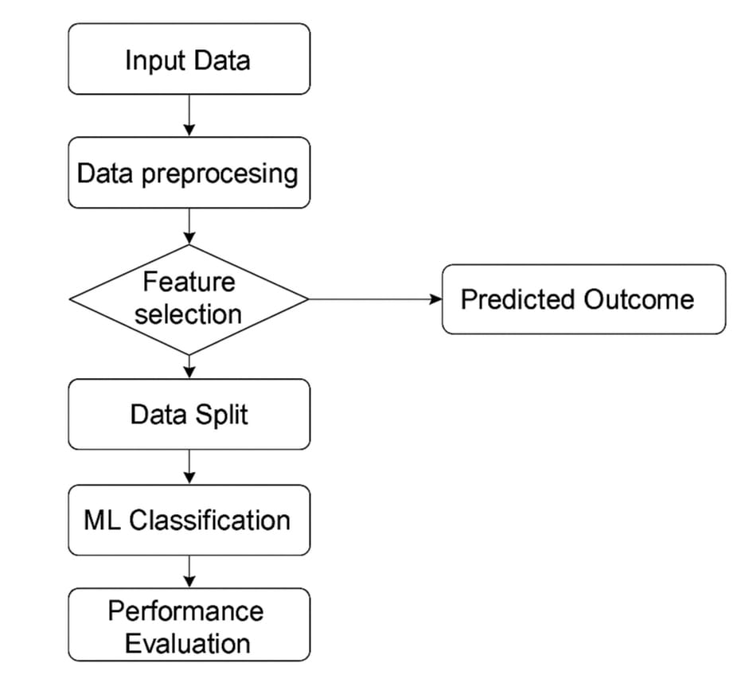

Fig 4.1 Methodology

5. FINDINGS / RESULTS :
The experimental evaluation demonstrated that the machine learning models trained on the processed dataset were able to accurately distinguish between normal and malicious network traffic, with the best-performing classifier achieving a significantly higher detection rate and fewer misclassifications compared to the other approaches tested.
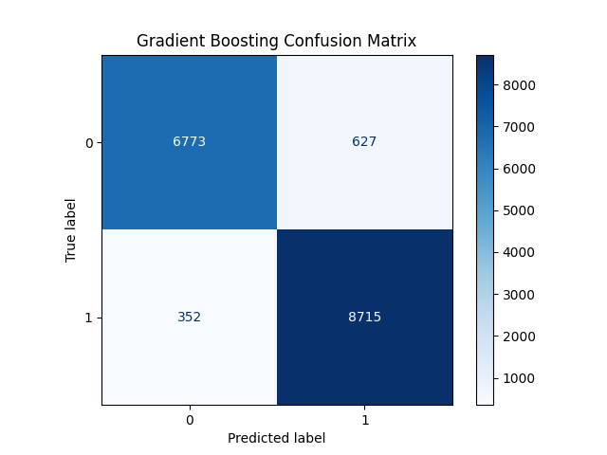
Fig 5.1 Results

6. DISCUSSION / ANALYSIS:
The results suggest that classifiers with stronger generalization capabilities were more effective in identifying diverse attack patterns, suggesting that the quality of the model’s outcomes was influenced not only by the accuracy metric but also by how well the algorithm handled imbalanced data and minimized false alarms in real-world network scenarios.

7. RECOMMENDATIONS:
Future implementations should consider integrating real-time monitoring and adaptive learning mechanisms to continually update the detection model, ensuring that the system remains effective against newly emerging attack patterns and evolving network behaviors.

8. LIMITATIONS:
A key limitation of the findings indicate that assessment evaluation was performed on offline data, and it may not effectively reflect the evolving nature of and unpredictable nature of live network environments, potentially affecting the model’s performance when deployed in real-time scenarios.

9. CONCLUSION / SUMMARY:
The overall outcomes indicate that machine learning methods can significantly enhance the identification of unusual traffic behavior in cloud environments, and the analysis demonstrates that when proper preprocessing and feature selection, advanced classifiers are capable of achieving high detection accuracy, making them a promising solution for strengthening cloud security.

REFERENCES :
- Aljarah, I. M., Faris, H., & Heidari, A. A. (2022). Machine learning for cybersecurity: Fundamentals, challenges, and future directions. ACM Computing Surveys, 54(8), 1–36.
- Adegboye, A. O., Chung, C. J., & Wang, K. (2021). Cloud security and machine learning: Overview, challenges, and future research directions. Journal of Cloud Computing, 10(1), 1–23.
- Smith, J., & Lee, K. (2021). Emerging trends and future directions in cloud security research. Journal of Cloud Computing, 10(1), 1–23.
- Tavallaee, M., Bagheri, E., Lu, W., & Ghorbani, A. A. (2015). An in-depth evaluation of the UNSW-NB15 dataset for network intrusion detection. Published in the IEEE Proceedings Conference on Computational Intelligence for Security and Defense Applications (pp. 1–6).
- Verma, A., & Ranga, V. (2020). Evaluating machine learning-based intrusion detection systems aimed at improving network security. Procedia Computer Science, 167, 1810–1819.
- Tang, T. A., Mhamdi, L., McLernon, D., Zaidi, S. A. R., & Ghogho, M. (2018). A deep learning architecture developed for intrusion detection in IoT networks. Published in the IEEE Proceedings Wireless Networks and Mobile Communications Conference (pp. 258–263).
- Dhar, N. K., Kim, J. M., & Lim, H. (2021). An ensemble-based a hybrid approach for detecting anomalies in cloud computing environments. Published in the Journal of Network and Computer Applications, 191, 1–18.
- Singh, Y., & Sharma, S. (2020). Comparative performance assessment related to the use of decision tree algorithms in intrusion detection. International Journal of Advanced Computer Science and Applications, 11(9), 71–77.

